Network Task

Task 1 –
Get the IP address of a domain (guvi.in)
We can use any of the below options:
Option 1: Using dig (Recommended, most powerful, preferred in DevOps and Best for Scripting, clean output, DNS analysis)
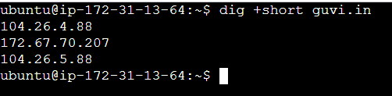

Option 2 : Using host (Quick, simple, human-readable DNS lookups)

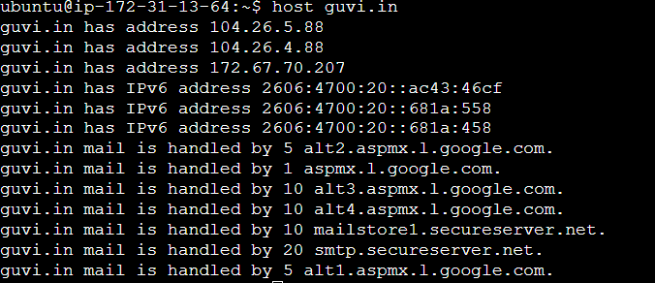

Option 3: Using nslookup (Quick check)
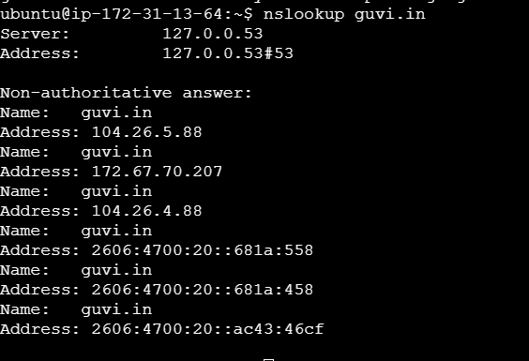
Option 4: Using ping (Quick check)
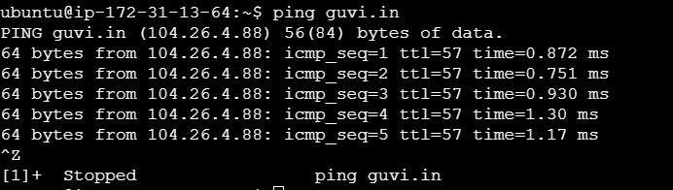

Option 5 : Using telnet to Get the IP Address of a Domain (guvi.in)
We can use telnet to see which IP address a domain resolves to when connecting to a specific port.
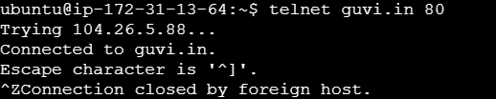
For HTTPS
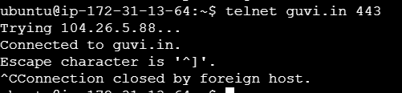
Check CPU/memory usage of my server
Option 1 :Using top (Most Common)
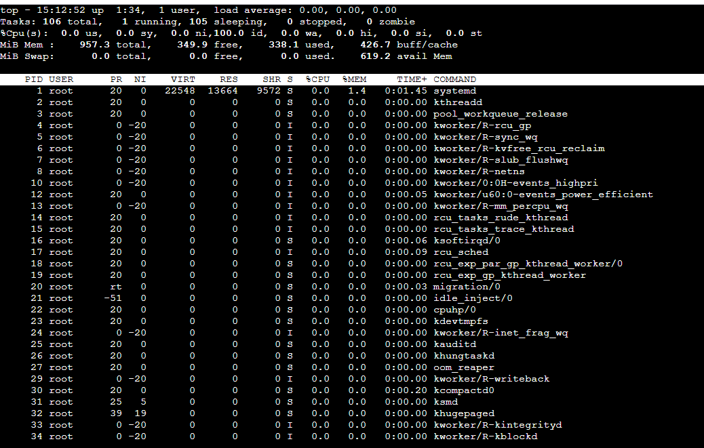
Option 2:Using htop (Better UI) look for: %Cpu(s) → CPU usage High load or processes consuming CPU
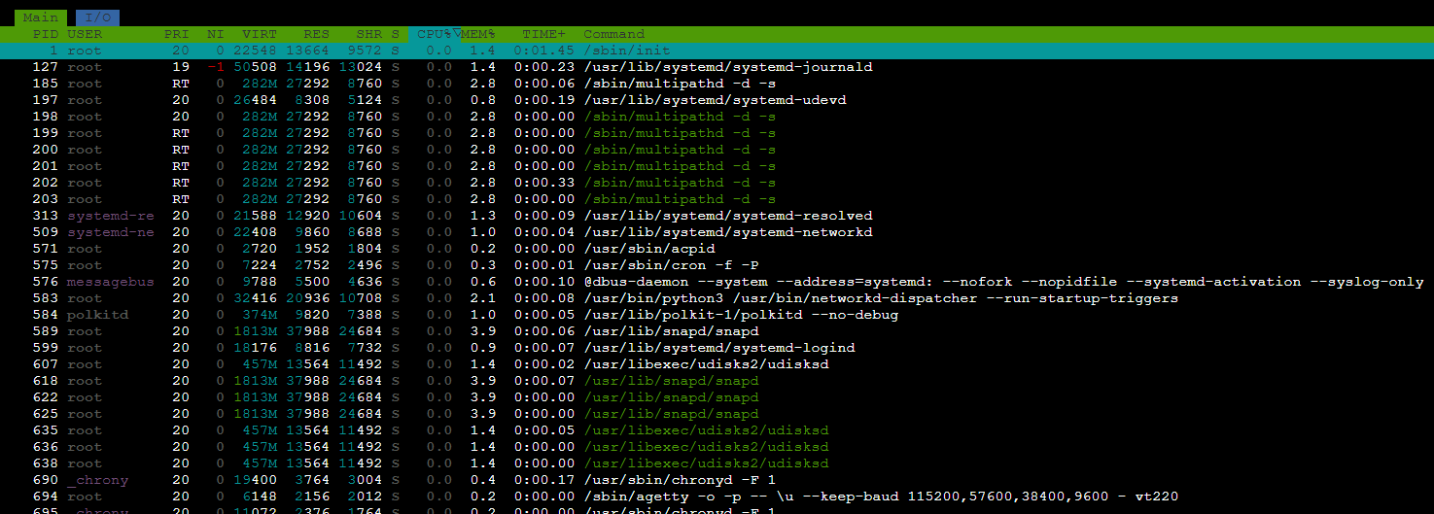
Option 3: Using free Check Memory Only
-h → human readable (MB/GB)
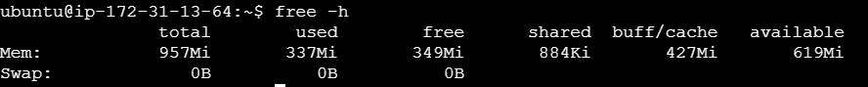

Option 4: Using mpstat Check CPU Usage Quickly
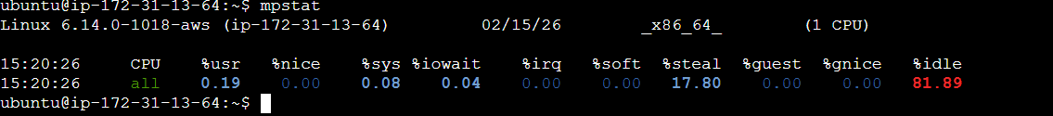

Option 5: Using vmstat gives information about processes, memory, I/O, and CPU activity.
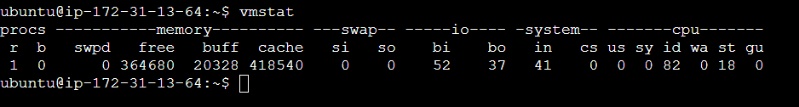

Option 6: Using uptime
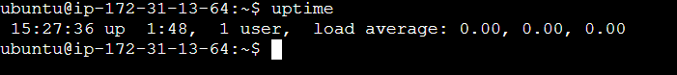
Understanding Load Average If your server has:
- 1 CPU core → Load > 1.0 = overloaded
- 4 CPU cores → Load > 4.0 = overloaded
Option 7: Using ps
Sort by CPU:
ps aux --sort=-%cpu | head
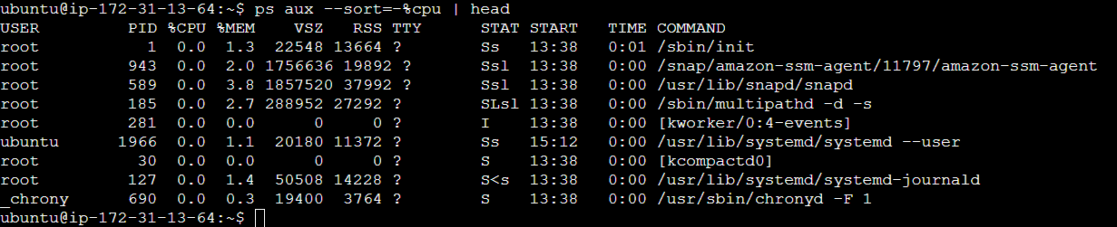
Sort by memory:
ps aux --sort=-%mem | head
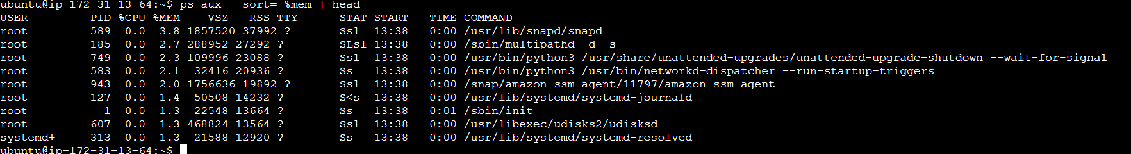

Test the connectivity between 2 nodes
Using traceroute
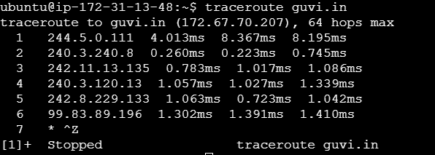

Using telnet
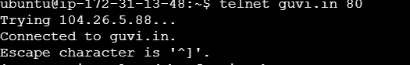
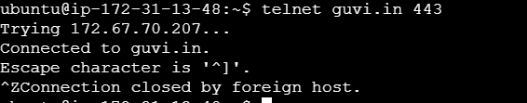

Using nmap we check whether the port is open or not
